**DSCI 5360 – 07 DATA VISUALIZATION FOR ANALYTICS**

**FINAL PROJECT:**

**Exploring Global Data Companies Salary Trends**

**Project by:**

**Sai Teja Kode**

**Table of Contents:**

**Introduction**……………………………………………………….………………..3

Variable Insights…………………………………………………………….3

**The rationale behind the data selection**……………………………………..5

**Problem Statement**……………………………………………………….…5

**Analysis**…………………………………………………………………………...6

**Multiple Visualizations** ………………………………………………….…..……7

**Dashboards** ……………………………………………………………………….18

**Story**…………………………………………………………………………..…. 21

**Business Implications**………………………………………………….…………23

**Conclusion………………………………………………………...………………24**

References…………………………………………………………..…………….25

**Introduction:**

The project on “Exploring Global Data Companies Salary Trends” primarily focuses on salary trends within the global data companies it captures various features that influence the salary across the data industries globally. This Project works with a database holding information on salary within the business intelligence and data science sectors. Visualizing regional salary differences across various countries and continents. Comparing salary Distributions among the different roles such as Data Analyst, Data Scientist, BI developer, etc. Investigating how experience levels correlate with salary variations. Exploring Salary structures based on Company size and location. Identifying and visualizing salary Trends over time.

**Variable Insights**:

The variables of the database are key in analyzing salary trends and inequalities: Job Title, that is, the position or rank of a person working in an organization; Company Size, classified as small, medium, and large, to understand the scale of operations and the associated impact on salary; Expertise Level, ranging from entry to executive, which gives a view into the career progression and salary growth; Location, that is, reflecting the area consideration in salary distribution; Employment Type, showing whether full-time, part-time, or contract, to explore the varying conditions under which salaries are paid; and Annual Salary, the dependent variable which shows the payroll amount.

The selected variables are relevant to current issues of transparency and equity in compensation within the tech sector. By means of this dataset, a study could be held on how different variables, such as position, company size, and location, influence the results of salaries and make available trends that could inform more equitable compensation practices.

The reason for such a choice, therefore, is the demand for the rectification of wide disparities in structures of salary influenced by confidential compensation policies and regional economic conditions. The specific areas covered will ensure the project will provide a comprehensive overview of such issues, for stakeholders to make informed decisions regarding career development, hiring, and negotiations of salary.

for recruiting talent. Thirdly, this research gives an insight into the current trends of the job market for data science professionals; one would find this very insightful indeed!

The dataset "Latest Data Science Salaries" on Kaggle has so many fields that offer different ways we might understand what people are paid in the field of data science. Here are some details about these variables:

**1. Job Title:** the title of a job describes the position being offered – a ‘Data Scientist’ vs a ‘Data Engineer’, for instance – and thus differentiates between jobs. This can be helpful to find a general impression of work in data science, as different similar job titles will reflect degrees of specialization and job content. For one example, some job roles may have expectations of higher salaries based on other things – the actual salary numbers of types of positions with the same job title vary greatly according to not only average salary but also perks packages related to specific duties.

2**. Employment Type:** It indicates job security, and influences salaries and benefits.

3**. Experience Level:** Sometimes the relevant job advertisement will state this explicitly, referring to the advertised role as ‘entry-level’ or ‘senior’ or the like. The pay scale tends to climb with years of experience –this is probably the most important factor.

**4. Expertise Level:** The expertise level required for the job is indicated by proficiency levels such as "Entry" or "Expert". This means that different skills or areas of knowledge may be considered as expertise concerning which earnings are determined. Understanding the impact of various forms of expertise on potential income is important.

**5. Salary:** This is a field that includes a figure representing the amount in the local currency stated on an employment offer for the position described. Also, it is significant when trying to find out why they vary across different aspects because salaries greatly depend on this factor.

**6. Salary Currency:** The kind of money used shows what country pays it, for example, US dollars would mean the United States is paying someone’s wage. Henceforth when conducting international comparisons one should always consider these little details so that there won’t be any misunderstandings due to misinterpretation.

**7. Company Location:** This specifies the employer’s site. It is essential to know this because pay may vary considerably due to differences in living costs or market conditions in different places, hence suitable to use in comparing incomes across regions.

**8. Salary in USD:** The field for salary in USD converts all amounts of money earned by an individual or given to employees as wages or remuneration packages into American dollars so that they can be compared with one another on a universal scale. Through this section, one can also track global earning trends and make valid company-to-company or person-to-person comparisons.

**9. Employee Residence**: This field informs us about the employee's place of residence, which need not be the same as that of his/her workplace. The salary is determined by both remote work and location. 10 Size of the Company: Physical Determinants of the Business Unit or Activity The size of the business entity or activity can be one of: small; medium; or large. Perhaps the size of the organization is a measure of its number of employees or the revenues generated. Perhaps the larger the asset base of the company, the more opportunities there will be for good higher-paid jobs. But then again, perhaps smaller companies offer more flexibility with a job: you can have a job there, but without equity-sharing. This helps to frame how big your business is, and what difference this makes to your salary.

**11. Year**: The year reflects when salary is provided. Salary can be expected to change over time. You need to have a point of comparison with the current market. These labeling variables let us focus and supplement our more qualitative account of data science pay structures, encouraging us to dig deeper into how pay has come to look this way.

**The rationale behind the data selection**

Along with the above purpose for the choice of the dataset, the characterization of the following variables will be adopted: Job Title, Company Size, Expertise Level, Location, Employment Type, and Annual Salary- those variables will allow for quick and comprehensive analysis of the dynamics of the data science labor market. These variables will provide a foundation upon which to analyze pay trends conditioned by experience and organizational scale impacts on pay and regional pay differences. This project provides analysis and visualizations that can give valuable information to stakeholders like job seekers in the data field employers, policymakers, and educational institutions. the project visualizations can help identify trends over time, evaluating the demand for specific data specific roles.

**Annual Salary:** this is used for valuation and appreciation of the financial compensation of positions in data science; it will help in the observation of pay trends conditioned by other variables.

**Job Title:** this will help analyze salary variation amongst diversified data science positions and hence understand how different levels of different positions are valued in the industry.

**Company Size:** this can be useful to underline the connection between the size of a company and the structure of salaries and hence make a difference between the pay levels of start-ups, SMEs, and large corporations.

**Expertise Level:** it is the leading variable that helps in understanding rising salary with the professional and a view of career rise in data science.

**Location:** it allows the study of regional salary differences which will be helpful for a company to decide where data science professionals may wish to work in terms of economic benefits.

**Employment Type:** information of this nature is crucial for segmenting data into trends specific to full-time, part-time, and contract employees, in order to highlight the difference in compensation.

**Problem Statement:**

Even though the data industry plays a vital role in the rapid growth of the world economy, there is a noticeable lack of thorough research on the disparities in pay that exist within this industry due to factors like location, job function, company size, and experience level. The project "Exploring Global Data Companies Salary Trends" aims to understand why these differences happen within the industry to promote fairer payment systems while also offering advice regarding how to close these salary gaps or disparities for both employees’ career growth and employers’ hiring strategies through data preparation, cleaning, analysis, and other data visualization techniques.

**Analysis:**

Insightful analysis and interpretation of the data:

The dataset consists of 3,300 items on the salaries of Data Science jobs that ranged from 2020 to 2023. Most job titles are Data Engineer and Data Scientist, full-time. Most of the salaries are offered in local currency and USD with an average of $142,096 and a standard deviation of $69,028, which suggests that salary is very dispersed. The most numbers are in the United States and the rank of the professional goes from junior to senior, and, of course, the salaries ascend with seniority. This dataset possesses distinct sizes of the company—suggesting that possibly organizational scale exerts some, but not necessarily significant, influence on compensation—an overall impression of data science salary trends which makes it clear that pay varies because of geographical location, experience, and firm size.

Identifies meaningful patterns, trends, and relationships in the data:

From the dataset at hand for Data Science salaries, some meaningful patterns and trends can be highlighted. It is from the period 2020 to 2023, with a variety of roles, such as Data Engineers and Data Scientists, primarily from the United States. Salaries ranged from USD 15,000 to USD 450,000, with a median of USD 136,000, which leaves significant variance related to experience and job title. Generally, senior roles and experts are mostly paid higher, meaning the value of experience and the specialized skills in the industry. Most of the data points clustered around the median, with some extreme values on the high side, meaning top-paid outlier positions in larger or highly profitable companies. This is going to show a large economic landscape on which these professionals operate.

Offers clear and well-supported conclusions based on the analysis:

Strong trend analysis drew strong conclusions: experience and skill, especially at the senior level, translate to high compensation. Due to the local economic conditions and cost of living, the site determines salary; however, pay is governed by the size of the company as well. The sums are from $15,000 to $450,000. Consequently, the data show there is plenty of room for wage increases for the data science career and that the profession has a wide salary range.

Demonstrates a well-organized and coherent layout of visualizations:

This shall standardize the appearance and feel of the Data Science Salary dataset making it a lot easier to work with and draw meaningful information from the data. The initial representation of the distribution and skewness of the data from the Data Science Salary dataset would be through a salary distribution histogram. Box plots based on a job description and location depict the differences and the outliers that show the disparity in the data. This may point towards a shift in the labor market or slow rises in salaries.

**Multiple Visualizations:**

We chose vibrant color palettes and simple, legible chart types that could render visually appealing, exciting data visualizations of the Data Science salary dataset. To show pay distributions, density plots or histograms are used. Add smooth gradients for a modern look. Interactive scatter plots can be used to explore correlations between pay and experience or firm size. Hover over the plots to get tooltips with more information. Use choropleth maps or heatmaps to visualize geographic information on regional salary differences. Simple, uncluttered layouts and interactive features should be used in each visualization to grab viewers' attention and allow them to explore data interactively.

Histograms or box plots for pay distributions and stressing the presence of outliers and central tendencies are great for the Data Science salaries dataset. Trendlines make the use of scatter plots more feasible—ideal for understanding the nature of the relationship between two continuous variables, for example, experience and pay. Stacked variations add more detail and indicate subcategories, such as firm size. Bar charts are best for comparing continuous categorical variables, for instance, average salary by job title or area. Color gradients in heat maps are used for displaying density and variation in two dimensions, for instance, locations and job titles, and wage levels. Temporal progression, for instance, the growth of a wage over a period of time, is ideally represented by line graphs. For each unique element of data, these visualization types have been chosen to maximize clarity and readability.

Readability improvements for the data science wage statistics visualizations include layout, labeling, and color schemes. Although each chart presents its data through labels and captions, color may suggest particular patterns and characteristics of the datasets. Tooltips subtract clutter from the display and enable more information inference because an additional layer of accessible data can be provided through an interactive chart. Conclusion To the degree that different methods integrate, the information becomes clearer and more accessible to the reader.

We start by plotting a global pay distribution histogram in order to provide a background first, and then we develop a logical and coherent structure of visualizations for the Data Science salaries dataset. We then show pay and experience in the form of a scatter plot. In order to facilitate comparisons, we use bar charts to compare incomes for different job titles and locations. We then let the heatmaps reveal regional and job title-specific wage disparities and density. We want each of these visualizations to have a clear title, short legends, and axis labeling. We want them to be logically placed, which will cause the eye to scan through the data in a stepwise increase of awareness.

**Visualization 1: Average salaries of employment type by year**

This graph demonstrates the average wage trends of full-time, part-time, and contract staff from 2020 to 2024, giving a visual overview of the salary adjustments that have occurred over these years under different working circumstances. There is a high point in the average pay of full-time employees in 2022. However, this is followed by a sharp fall, and by 2024, it goes back to the levels that were at the start of the period. This could mean a major correction in the market or that the salary scale was adjusted to cause an abrupt increase in the full-time wage rates.

On the contrary, part-time employees’ wages hardly change significantly; there is only a slight increase in 2021 then they start decreasing gradually. This suggests that the part-time sector is relatively stable because compared to full-time jobs, these are not greatly affected by any economic or market factors. However, freelance workers consistently earn less than those working either as full-time staff or part-time workers. Still even after going up a bit in 2021.

Distinct color coding and smooth line representations on the schematic make comparison easy across different employment types. According to the salary trajectory of each group, it is easy to track visually. What matters most is that this arrangement helps data be understood immediately as well as meeting strategic planning requirements which involve indicating key trends and pointing out potential problem spots for entities seeking cost management solutions concerning remuneration budgets and shaping well-informed labor policies. Organizations need to appreciate such changes so that they can always modify their financial strategies without any difficulties when there are shifts within economic environments; this should be done while considering staff morale alongside saving money.

**Visualization 2: Total salaries of company size and expertise level**

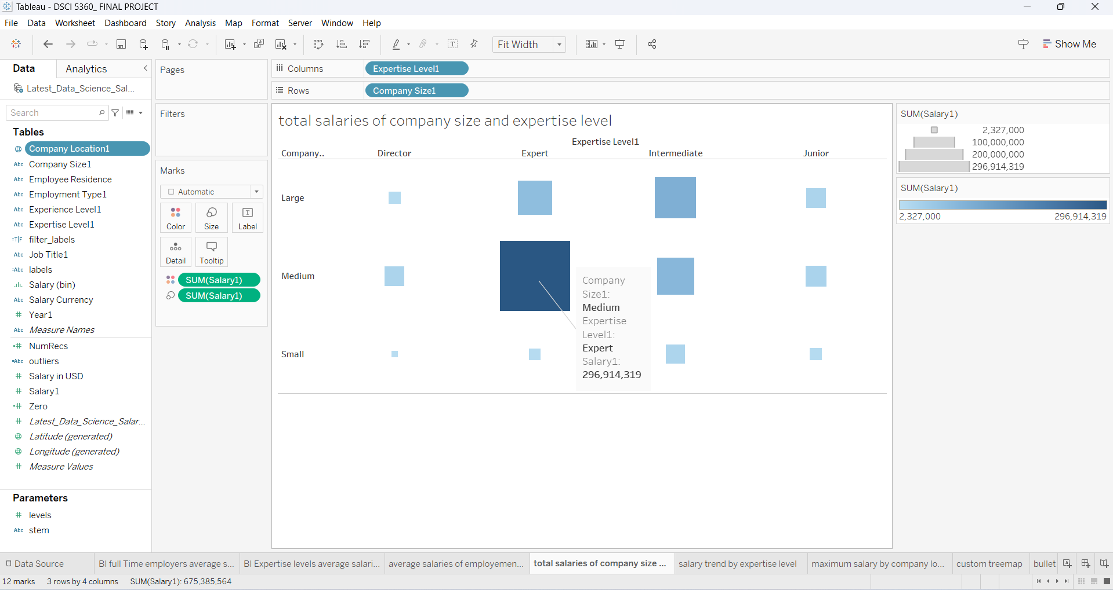

The graph presents salary distribution depending on the size of the company and the level of expertise of its employees. It uses size-based coding to depict total wages in various groups, thus enabling us to easily identify patterns and disparities.

Concerning company size, three categories namely Large Companies; Medium Companies, and Small Enterprises have been created. Under these divisions, there are further breakdowns according to skill levels: Directorial positions, professionals’ roles (experts), middle management cadre staff (intermediate), and entry-level workers (juniors). Each square on the graph stands for the total pay received by people within an area shown by the same color. Therefore, one can quickly determine how salaries are distributed across different variables visually without having to do any calculations.

For instance, analyzing data from the biggest firms reveals that those who fall under professional roles take most money home which is represented by a bigger size box towards their end. This indicates that organizations with higher revenues are more likely to heavily invest in individuals possessing critical skills or vast experience probably as part of driving strategic objectives or overseeing major projects. Directors also get handsome packages but not as much relative to what experts receive in such companies.

For Medium-sized companies, the salary distribution is significantly distinct. The highest overall salaries are seen in the Intermediate level. This could mean that there are more employees at this grade or an organizational strategy that places a premium on middle-grade professionals who are seen to be critical in the daily running of the business. Other proficiency areas have much smaller wage squares, reflecting less expenditure on relatively higher or lower specializations as compared to the Intermediates.

Small firms have almost equal pay dispersion at diverse levels of expertise, albeit relatively lower when compared with bigger ones. It suggests an even investment pattern for all tiers of professional knowledge. Such behavior is characteristic among petite establishments where job descriptions may overlap frequently and there may be less emphasis on hierarchy.

Overall, this graph effectively illustrates different establishments distributing their remunerations across employee skills in dissimilar ways. The giant firms prefer highly specialized personnel while those of medium size.

**Visualization 3: Salary trend by expertise level**

The graph shows salary information divided by different levels of expertise, specifically looking at the 'Expert' and 'Junior' groups. This is illustrated through a mix of box plots that briefly outline the salary distribution within each level of expertise.

Regarding the 'Expert' group, which is located on the left-hand side of the graph, the box plot reveals that their salaries have a wide range meaning there is a significant difference in payment among them. These differences could arise from varied length of service, different job descriptions falling under what is considered expert, or even wage disparities existing between industries and/or companies. The scatter points are centered around halfway through this salary band but also exhibit outliers towards higher values; this highlights instances where some individuals within this category earn substantially more than others.

Junior’s level appeared on the right side of the graph with a narrower salary range in the box plot, implying that the salaries of junior employees have less variability. This is common in positions where less experience is needed and pay scales tend to be more fixed. There are fewer scatter points for juniors, which are also less spread out than those for experts; this further reinforces the idea of more evenly distributed compensation at this level.

When combined, box plots along with scatter points effectively show both central tendency as well as dispersion of salaries per level of expertise. In the case of experts, a wider range along with some high outliers might indicate a premium being placed on certain types of knowledge or skills; meanwhile, tighter clusters seen among data representing junior staff would underscore their entry-level status with relatively little pay variance.

**Visualization 4: Maximum salary by company location**

The following map will show the maximum incomes distributed based on the geographical locations of companies. The size of each circle and the color would indicate the amount of money people make at that location, to make it very easy for us to see fast if salaries are the highest or lowest in any part of the world.

It seems that Europe features the most highly paid jobs with darker circles around Germany and France, the latter being much bigger than the former compared to the other countries on this continent. However, if we look at Buenos Aires—an abnormally large yellow spot among smaller ones surrounding it constitutes a similar case study for South America—salaries might be particularly good there because of certain industries thriving there, or big corporations having their headquarters based in that city.

The smaller, lighter-colored circles in Asia, especially on the island of India and in China, the two largest nations, denote lower salaries relative to Europe and Argentina. This concentration probably reflects regional economic conditions, the character of local labor markets, or dominant industries. For multinational companies, such a map is very useful in estimating global wage structures and regional market-entry strategies. For job seekers, it may serve as a guide to the locations of the most lucrative job opportunities in the world.

Overall, this map is a very important tool for understanding geographical differences in the possible amounts of salary, which is vital for companies to do strategic planning and for workers who may consider a career abroad.

**Visualization 5: Custom treemap**

The treemap shows average salaries for every kind of job type and level. In this treemap, each rectangle represents a type of job, and its size likely represents the number of individuals within a given category, though it is not an explicit metric of this representation. Colors are randomly assigned and do not show an apparent indication of any kind of trend or classification other than the diversification of the classes.

From this treemap, different job categories are observable, which shows the diversification in the salary within the framework of the kind of employment type and seniority:

Freelance Mid is the most highly paid job category within the dataset: its average salary is $520,311. One would reason that mid-level freelance positions are fairly highly paid given this. Perhaps this is because the demand for particular skills on a flexible basis is high.

Contract positions present a good number of salaries ranging from $416,000 to $80,472. The highest salary among all the contract positions presented is the Contract Executive salary. Other than this, two contract positions have average salaries considerably below the Contract Executive. From there, it can be said that a specific executive role within the contract job

positions is very well compensated. Such a position is loaded with high responsibility and has a flexible nature. Such a fact is almost sure to command a premium.

Full-Time positions vary widely with Executive earning around $236,262 and Entry earning $209,710. On the lower end of the salary spectrum presented in this visualization, Part-Time and Entry-Level Freelance positions are placed with the Part-Time Entry earning $80,472 and Freelance Entry earning $75,000. Such figures are naturally expected as entry-level and part-time positions usually offer lesser compensation reflecting the lesser experience requirement and fewer hours worked.

As a whole, the treemap is excellent for making space a premium for communicating the relative average salaries of different types of employment and levels, enabling a quick and immediate visual comparison. This type of visualization is very handy when it comes to quickly identifying which type of jobs and employment statuses are connected to higher or lower average salaries, valuable for strategic business planning, and career guidance.

**Visualization 6: Salary percentage of BI employees by company size**

The Donut chart portrays the total salary distribution of BI employees based on the company size category. Here, the chart can be interpreted on how the proportion of a whole is shared within different categories: that is, how the proportion of total salary allocated to large, medium, and small companies breaks down.

The largest slice of the total salary has gone to the large companies at 72.82%. This has been the largest share to make a difference between large companies and the others, probably because a larger number of employees and the associated higher salaries would mean it is bigger in number.

Medium-sized companies make up 25.35% of the total BI salary expenditure. This large share speaks volumes to the difference in strength for medium-sized companies' strength in terms of size for BI workers, even though it is relatively smaller compared to large companies.

Finally, small companies, to nobody's surprise, are given the smallest slice at 1.83% of the total BI salaries. This means small companies probably employ fewer BI personnel, thus paying out less in salaries or both. So small companies have a smaller percentage, and this shows they are not as robust to compete with medium and large companies in terms of the pack of salaries.

The Donut chart speaks louder about how the size of a company correlates with the amount of salary spent in the expenditure in the BI sector. It tells the story of how large companies are significant contributors to employment and salaries but small companies have little representation in the salary market, with huge disparity in economic muscle and workforce size for different company categories.

**Visualization 7: Bullet chart comparing median and average salary**

The bullet chart compares median and average salaries for various BI roles at different levels of expertise. A bullet chart can be used to display performance data such as actual performance to target or benchmark. In this case, the median salary is benchmarked against average salaries.

In the visualization, every role and level of expertise is represented by an individual bar, with the median salary showing a short bar or line and the average salary using the length of the main bar. Differing colors within the bars may be a measure for outliers within the salary data. The average salary of $150K is much larger than a median of $128K, indicating some individuals are paid much above the median. This type of skewness will push the average way up.

The average salary is $128K versus a median of $67K. That is a large difference that will indicate extreme values at the top. These extreme values will drastically jack up the average and push it above the median.

The average and median salaries are close to each other, with an average of $88K and a median of $63K. Here, the average and median are closer, and the salary distribution looks more uniform compared to the Director and Expert levels.

Junior BI Analysts have a small difference between the median ($58K) and the average ($76K), and between BI Developers, there is a median of $60K and an average of $130K. In the case of BI Developers, one might see a few extreme earners to push the average way up.

This bullet chart effectively embodies a huge difference between the average and median salaries, and thus it would demonstrate there are quite a few high earners that will tend to push the average salary figures up in general. This type of visualization would, of course, allow for an understanding of the salary distribution, and is especially useful for human resources to identify salary disparities and for potential job candidates to understand compensation dynamics within the field.

**Visualization 8: BI full-time employers' average salaries**

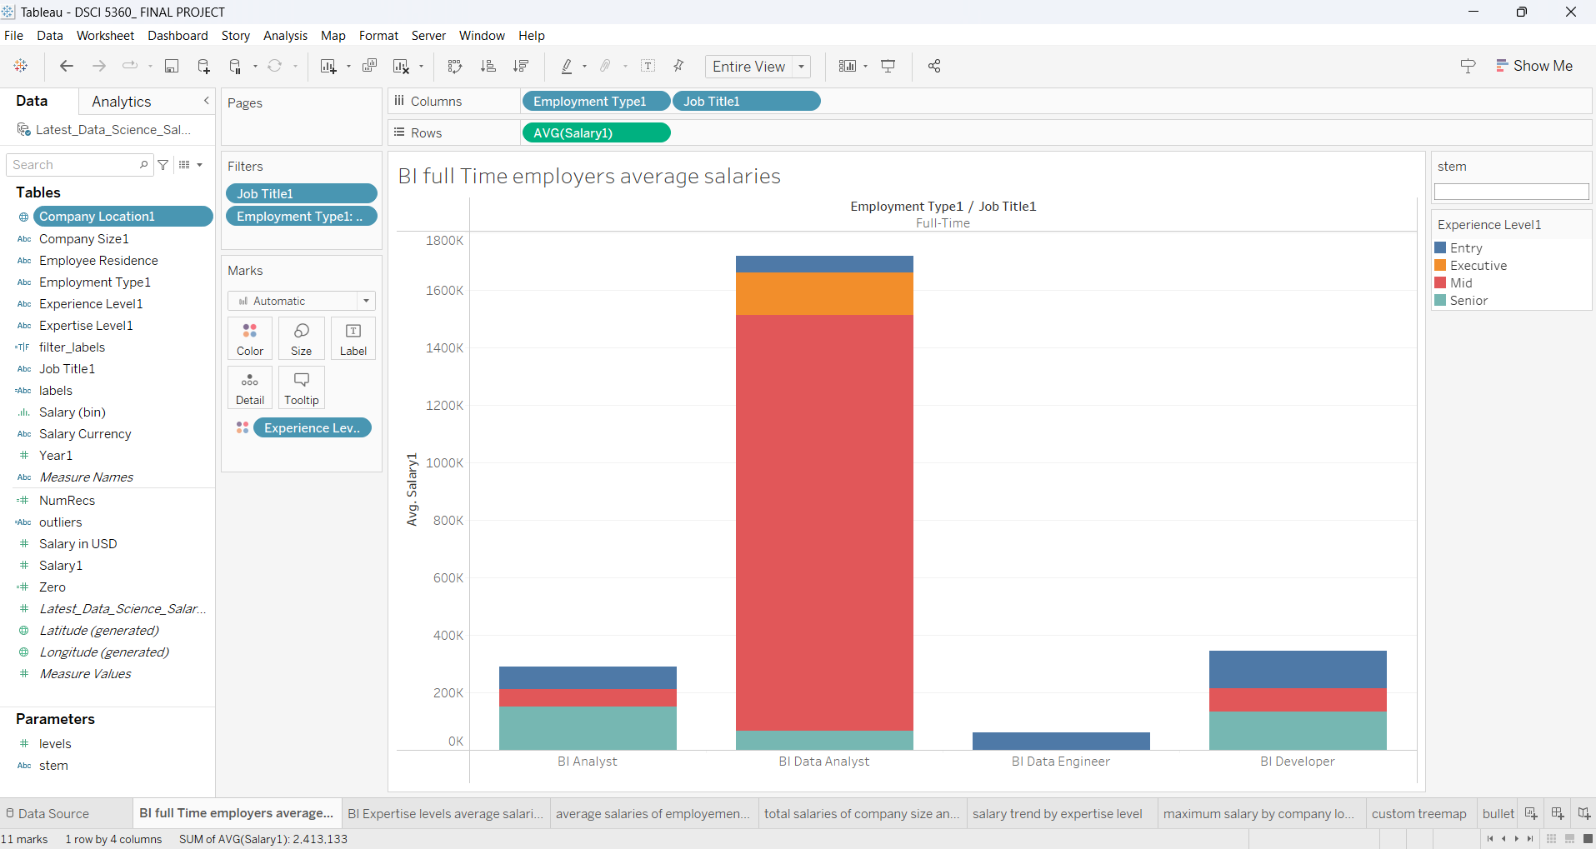

The bar graph represents the average salaries of the full-time BI positions broken down by experience level for the three categories: Entry, Mid, and Senior, and one of the higher experience levels: Executive. Each column represents a specific job title and the experience levels within it, colored inside each column.

This job seems to have minimal differences in average salaries for each experience level, with the least significant variation between the different experience levels. This job appears to have one of the lower-scaling and less variable scales of pay for seniority.

This job seems to have a high rate of increase in average salary for an increase in experience level, and especially for executive-level BI jobs. It shows the high value placed on experience and seniority.

Also has a high increase in average salary with experience levels, especially for executive-level jobs, and it shows the high value placed on advanced skills and leadership in data engineering.

This is the only job that had little difference in salary from experience level to experience level. The relatively flat salary structure in this job appears to hint at its role.

**Visualization 9: BI Expertise levels average salaries**

A bubble chart shows the average salaries for various levels of skill in business intelligence. The size of each bubble reflects the typical pay for that experience, thus highlighting differences based on where someone is in their career.

The largest bubble on the chart, located at the center of it, shows the average salary for a person with intermediate expertise – $857,750. This value is wondrously higher than the one for any other level of skill. The strange thing is that it seems to be quite rare for people at this skill level – even rarer than directors – to have such a high salary, therefore there are some skills or perhaps some specific knowledge highly appreciated at this stage, which might be understood within certain branches only, wherefore couldn't it be taken as evidence showing that Intermediate Level has fewest experts thereby making demand outweigh their supply hence leading companies pay more money as remuneration for their services.

On the flip side, the bubbles for the Junior, Expert, and Director levels display more traditional salary distributions. The smallest of these bubbles is for junior positions which reflects an average wage of $78,250 which is typical in most cases where entry-level jobs earn less. Experts earn a little bit about one hundred thirty-nine thousand six hundred sixty-four dollars but not more than a hundred fifty thousand dollars in case it is directors who generally oversee multiple projects or departments altogether. In the meantime, while moving from one level to another between junior and director stages, what is usually seen is increased responsibility as well as more specialized skills being acquired along that line even though we have this data set showing otherwise by having its peak at intermediate level which deviates significantly from what was expected.

Overall, this graph gives a lucid and terse illustration of the salary disparities among different levels of skills in business intelligence, indicating the outstanding regard for the medium skills in this data set. It may be worth investigating further to understand what contributes to such high remuneration at this point.

**Dashboards:**

**Dashboard 1:**

This visual shows well how lucrative full-time BI professionals are, as well as the mid-level positions, peaking at $1.44 million while showing the highly valued expertise of these professionals. Salary trends for the last few years show rapid growth, and this growth indicates strong dynamics and rewards that necessarily come with having a career in BI.

**Dashboard 2:**

The chart provides an insight into the company size and location related to BI salaries. From the chart, one can take the lead to say that the maximum salaries are paid to experts in medium-sized companies. Salaries are also high at one or two locations. For example, one can find such locations in Chile, where the highest salary is stated to be $30.4 million.

**Dashboard 3:**

This visualization illustrates the salary distribution in the roles of business intelligence and firm size, where more than 72 percent of all BI salaries are attributed to large-sized companies and also to diversified BI roles like Freelance Mid and Full-Time Executive which give top pay.

**Story:**

Examining business intelligence (BI) salaries tells the story of expansion and expertise. The survey kicks off by giving the average annual salaries of BI full-time workers and the salary peak is at $1.44 million for the middle level which is sharply different for the junior and senior levels. It therefore seems that there are certain specialized skills gained by mid-level employees. This can also be supported through trend analysis which shows a continuous rise in salaries over the years thus signifying increased demand for BI skills across different industries.

it goes into greater depth when it comes to worldwide perspectives by pointing out that company size and location also have an impact on how much people get paid in the business intelligence sector. For instance, medium-sized enterprises situated somewhere like Chile show huge investments into BI knowledge with salaries going up to $30.4M being offered. This part of the story highlights both an international acknowledgment of these types of skills as well as underlining just how much strategic value organizations attach to them when fostering decision-making based on information.

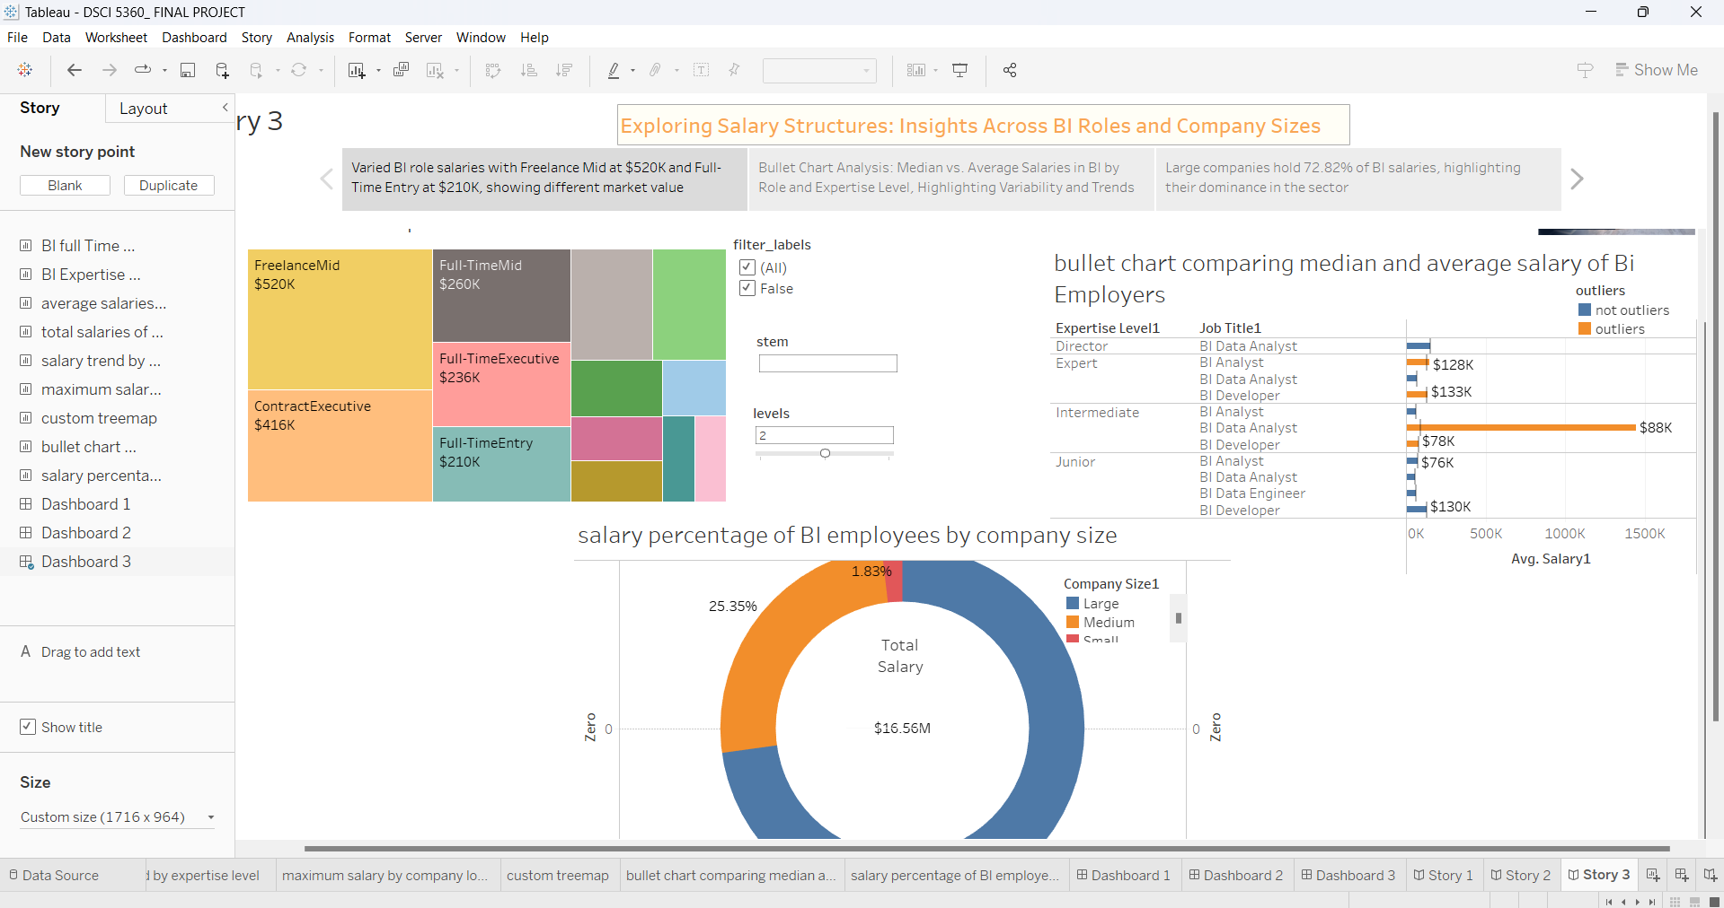

In organizations, salary distributions in different business intelligence (BI) roles are compared as well as across company sizes. This part displays the many different salaries available and the fact that freelance mid-level positions can pay up to $520K, showcasing an adaptable market driven by demand. A graph of the percentiles of wages based on firm size shows us that this industry’s workforce is mostly under — they make up 72.82%. It reinforces how important big players are in shaping these employment landscapes around Business Intelligence.

**Business Implications:**

The project successfully facilitates data-driven decision-making:

For that, the project gives a wealth of data containing important elements of job title, experience, and location, which are required for rich analysis. This will enable data-driven decision-making since it provides concise, yet easily understood insights through well-designed visuals, which will make it easier for the stakeholders to understand the complexity of data. It promotes a high level of comprehension and gives actionable results for businesses that can be derived from the information it receives as a change of hiring practices and pay scales, among others. With all that has been said, the strength of the project lies in its ability to turn complex data into an easily understandable and applicable decision on different organizational levels.

Indeed, the insights and visualizations are applicable to the business environment and actionable:

In fact, the data visualizations and insights from the Data Science salaries dataset could be used to guide strategic hiring decisions with comprehensive salary data from job titles, experience levels, and regions by enabling any company to set competitive and equitable salaries. Besides, insights are how structures may be used to optimize compensation packages to allocate resources effectively for best impact in a problem-centric and high-value area. In fact, trend analysis from the data aids in making long-term plans and adjustments in strategies to the response of the changes in the labor market, and these insights would be worth using as an important basis for informed decision-making regarding recruitment and compensation strategies.

The project does, in fact, support tactical, operational, and strategic choices. It informs strategic decisions in the long run on expansion in other geographical areas and pay scales compensated in terms of the statistics available at the time. At a tactical level, it helps workforce planning and pay scale adjustment with the help of market statistics available at the time. At an operational level, it helps the managers and the HR to negotiate wages and give employment offers every day to ensure the same is equitable and builds team spirit. Hence, the dataset will be a general resource that guides decision-making at all levels of the organization.

The project that uses the Data Science salaries data far improves key performance measures by allowing competitive wage packages that will reduce staff turnover and increase staff satisfaction. It uses recruitment efficiency and improves the quality of hire by streamlining the process. Precise information on market wages enables efficient budgetary control and the computations of personnel costs at the same time, strengthening recruitment efforts through the attraction of top-tier experts. All these put together support strategic workforce planning and operational efficiency.

**Conclusion:**

The project “Exploring Global Data Companies Salary Trends” will point out areas where pay cuts are possible but will not make them gap the industry standards and not sacrifice the quality of people employed in pinpointing those where pay is costly compared to what is afforded in the market nowadays. On the other hand, the company may discover novel and lucrative market niches or services to meet escalating demand to maximize profits by investing in in-demand talents or duties that command higher pay. Therefore, this strategic insight will help the companies to take full advantage of new opportunities and use their resources well.

This project reflects the most promising investments in talent development and recruitment through the salience of demand for various data science professions and related salary patterns. Clear, actionable data, which can provide cross-departmental collaboration from HR to strategic planning, provides good stakeholder engagement as all decisions will be in line with organizational goals. It also provides the organization with a competitive advantage in attracting and retaining leading staff, optimizing budget allocations, and finding market opportunities critical for maintaining and raising market position through complete compensation analytics.

**References:**

1. Latest data science salaries. (n.d.). Kaggle: Your Machine Learning and Data Science Community. <https://www.kaggle.com/datasets/iamsouravbanerjee/data-science-salaries-2023>
2. Ohmann, A., & Floyd, M. (2015). Creating data stories with tableau public. Packt Publishing.
3. Batt, S., Grealis, T., Harmon, O., & Tomolonis, P. (2020). Learning Tableau: A data visualization tool. The Journal of Economic Education, 51(3-4), 317-328.